8th INTERNATIONAL PIANO COMPETITION «EUROPE – ASIA»
(14-18 June 2016, Orsk, Russia)
Application form

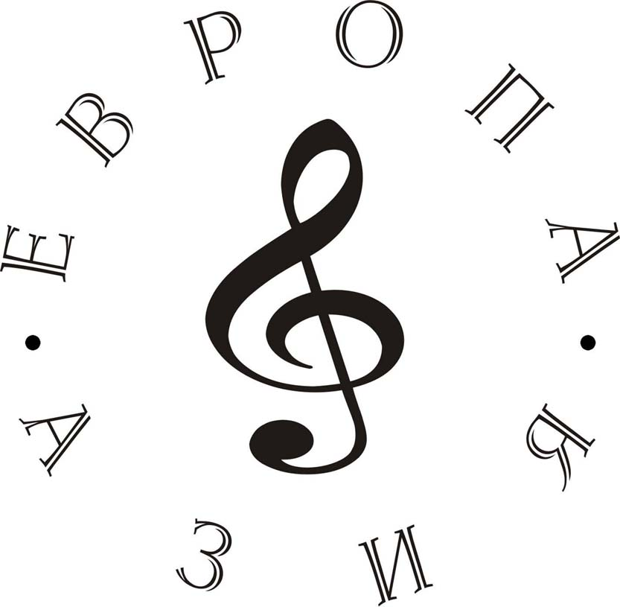

Category
Surname and Name
Passport
Issue
Expiry
Date of birth
Place of birth
Full address
Phone
e-mail
Teacher Surname and Name

PROGRAMME
(Composers, Titles)

1.
2.
3.
4.
5.
6.

ACCOMPANY:

Surname and Name
Passport
Date of issue
Date of expiry
Date of birth
Place of birth
Full address
Phone
E-mail

Date_________________________________ Signature_______________________________
Parent signature for minors__________________

The deadline for sending the application form is May 15 2016.

