8th INTERNATIONAL PIANO COMPETITION «EUROPE – ASIA»
(14-18 June 2016, Orsk, Russia)
Application form

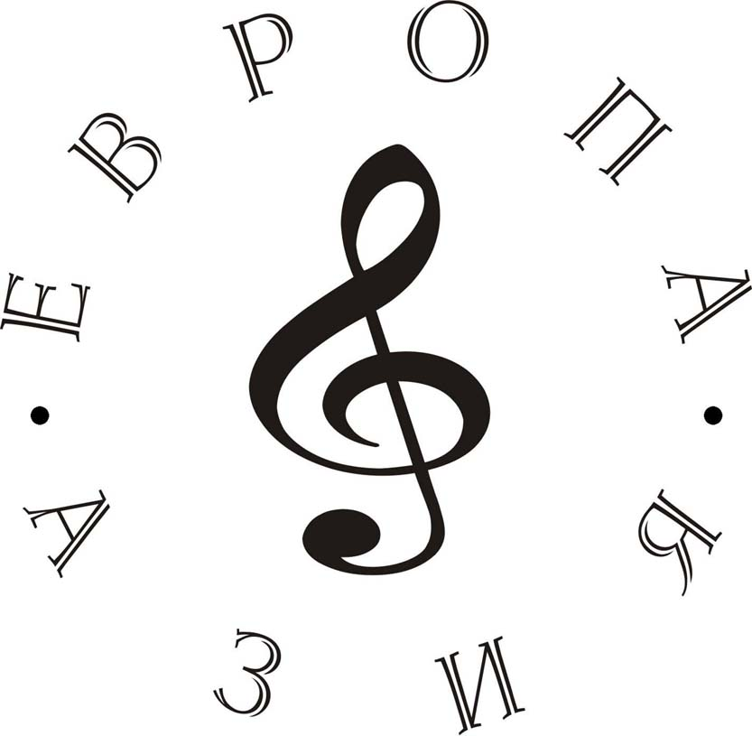

Category  E  F
Surname and Name_____________________________________________________________
Passport___________________________Issue__________________Expiry_______________
Date of birth__________________________________________________________________
Place of birth__________________________________________________________________
Full address___________________________________________________________________
Tel.:__________________________________ e-mail_________________________________
Teacher Surname and Name_____________________________________________________
Full address___________________________________________________________________
Tel.:__________________________________ e-mail_________________________________

PROGRAMME
(Composers, Titles)

1st round
1._______________________________ 4.______________________________
2._______________________________ ______________________________
3._______________________________ ______________________________

2nd round
1._______________________________ 4.______________________________
2._______________________________ 5.______________________________
3._______________________________ ______________________________

Date_________________________________ Signature_______________________________
Parent signature for minors__________________

The deadline for sending the application form is May 15 2016 to:
462404, Russia, Orsk, ul. Neftianikov 1b, Detskaya schkola iskusstv №2, Competition «Europe – Asia»

